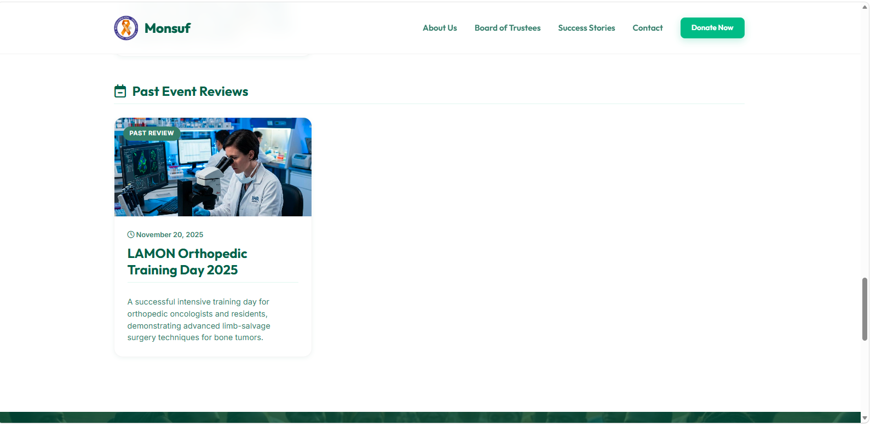
Updated the past events with the 2026 School Cancer Awareness Program

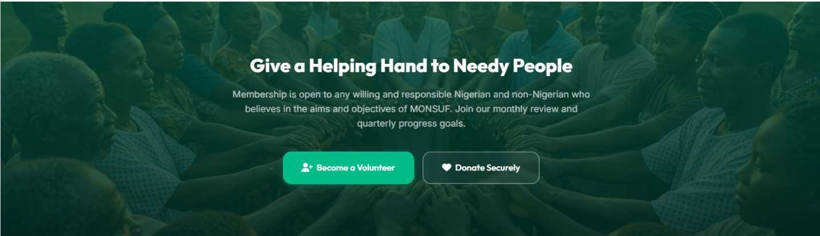
Change “give a helping hand to needy people “ to “Join the Fight Against Sarcoma" or "Become Part of the Mission."

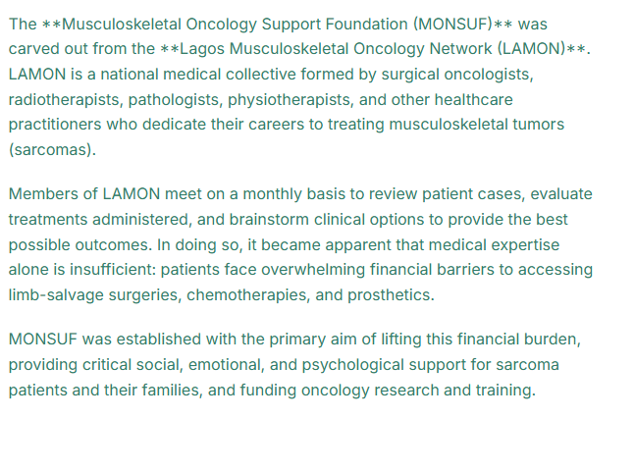
Correct the asterix (**) display, I suppose Musculoskeletal oncology support foundation (Monsuf) and Lagos Musculoskeletal Oncology Network (lamon)

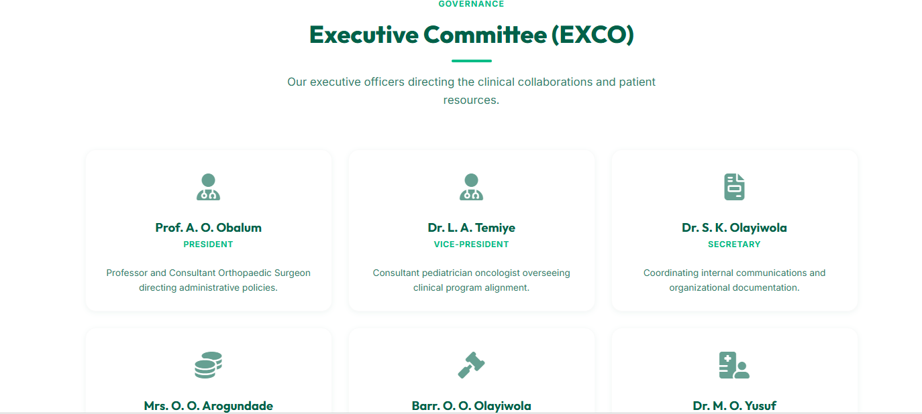
Change this EXCO section to a gallery section


Please remove the image used in contact & volunteer section and put it in board of trustees section



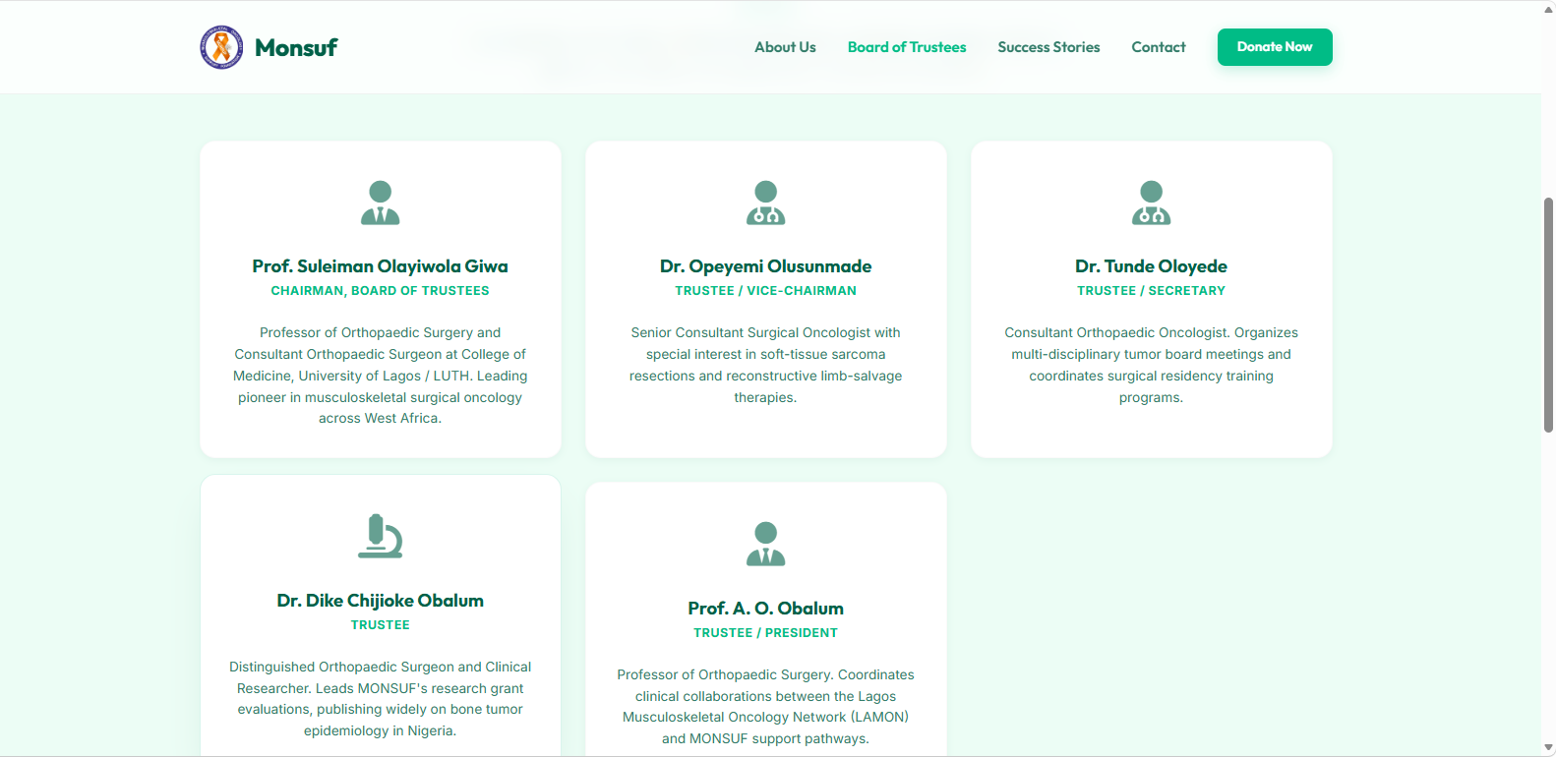
Add the board of trustees with their corresponding images

